**PYTHON PROGRAMMING**

**ASSESSMENT – 1**

**Lab Challenging Exercise - 1**

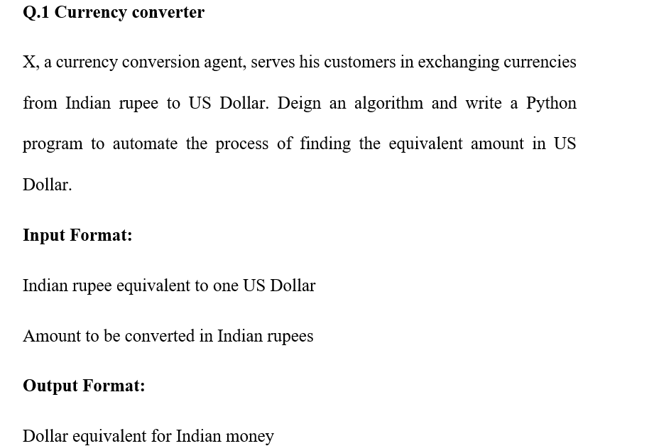

**CODE:**

# Currency Converter Program

# rsVal to store float type value in rupees equivalent to 1 dollar.

rsVal = float(input("Enter ₹ Equivalent to $1: "))

# amount to  store the float type value in rupees to be converted in dollar.

amount = float(input("Enter amount(₹) to be converted in $: "))

#dollarVal to store the equivalent dollar value to amount given in RS. upto 2 decimal places

dollarVal = format(amount / rsVal, ".2f")

#Displaying the final OUTPUT in dollars

print( "The Dollar Value equivalent to ₹", amount, " is: $", dollarVal)

**SCREENSHOT OF OUTPUT:**

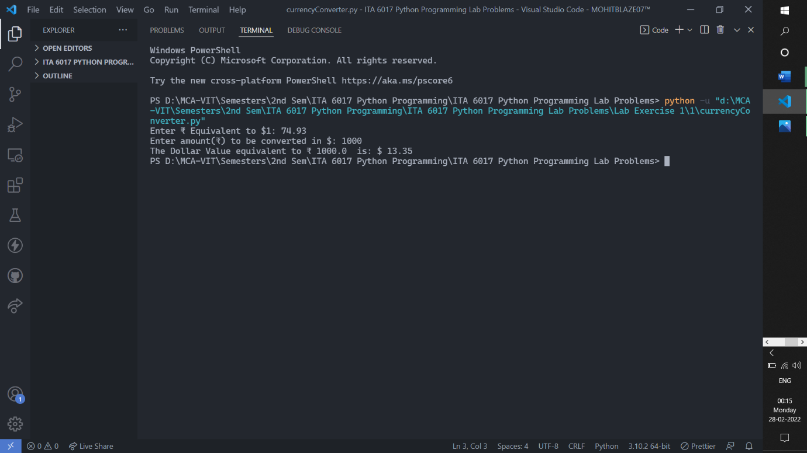

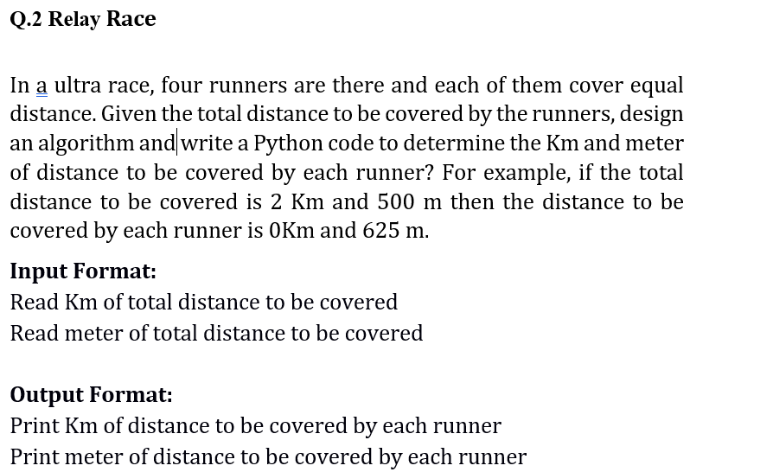

**CODE:**

                    #Relay Race Problem

print("Total distance to be covered: \n")

#get the km value to be covered from user.

kmValue = int(input("Enter the value for Km's: "))

#get the m value to be covered from user.

mValue = int(input("Enter the value for Mts's: "))

#converting the km into m

kmInM = kmValue*1000

#computing the total distance to be covered in metres.

totalDistanceInM = kmInM + mValue

#computing the total distance each runner will be covering.

distToBeCoveredByEachRunner = totalDistanceInM//4

#checking the distance is less than 1km or not if yes then just print the m value and print km as 0.

if( distToBeCoveredByEachRunner < 1000 ):

    print("0 Km and ", distToBeCoveredByEachRunner, " m.")

#if distance is greater than 1000... then compute the respective km value and m value.

else:

    ansKmVal = distToBeCoveredByEachRunner // 1000

    ansMVal = distToBeCoveredByEachRunner - ansKmVal * 1000

#print the km ans value and m ans value

    print(ansKmVal, "km and ", ansMVal, " m.")

**SCREENSHOT OF OUTPUT:**

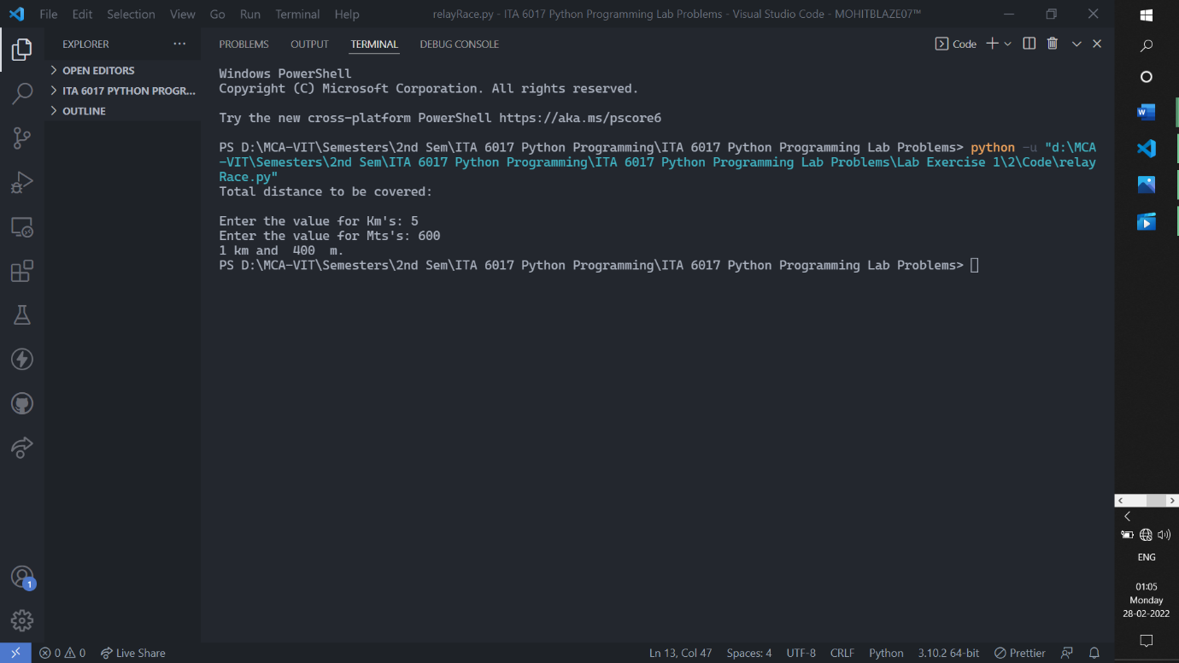

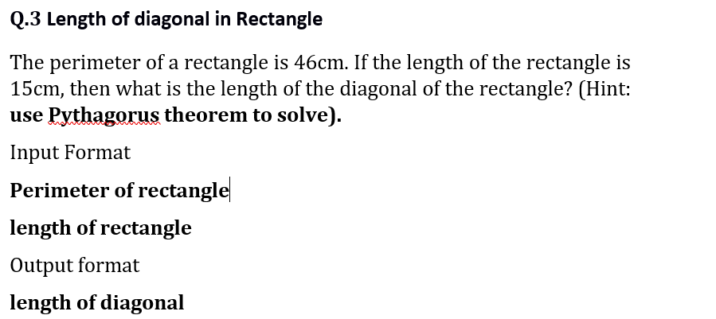

**CODE:**

#importing the math package module to use square root method.

import math

#reading the perimeter value from user.

perimeter = int( input("\n Enter the perimeter of rectangle: ") )

#reading the length value from user.

length = int( input("\n Enter the length of rectangle: ") )

#finding the breadth of rectangle.

breadth = (perimeter // 2) - length

#computing the ans using pythogoras theorem

ans = length**2 + breadth**2

#computing the diagonal length.

diagonalOfRectangle = math.sqrt(ans)

#displaying the diagonal length of rectangle

print("The diagonal length of rectangle is: ",int(diagonalOfRectangle),"\n")

**SCREENSHOT OF OUTPUT:**

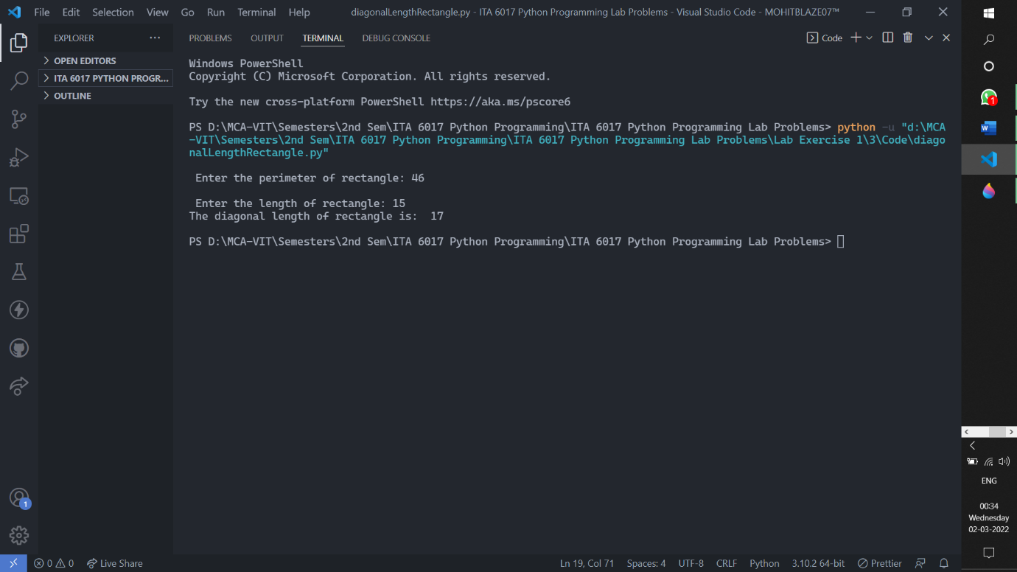

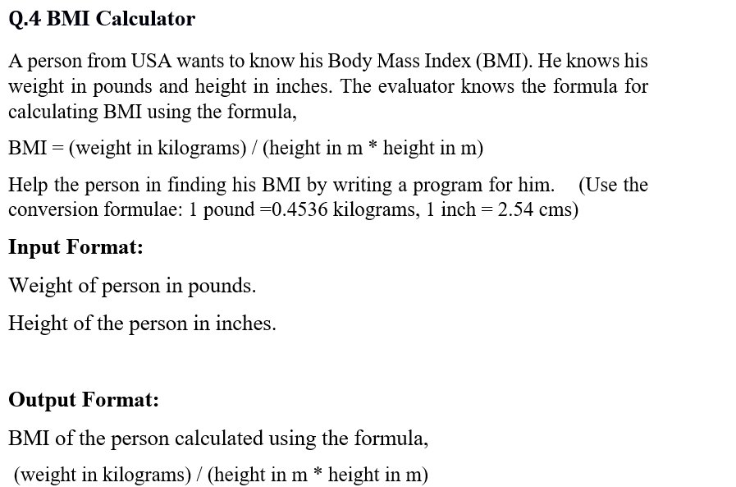

**CODE:**

weight = float(input("\n Enter the weight value in pounds: "))

height = float(input("\n Enter the height value in inches: "))

onePoundValue = 0.4536

oneInchValue = 2.54

weightInKg = weight * onePoundValue

heightInM = height * oneInchValue

bmi = format((weightInKg) / (heightInM ** 2), ".2f")

print("The BMI value is: ",bmi,"\n")

**SCREENSHOT OF OUTPUT AND CODE:**

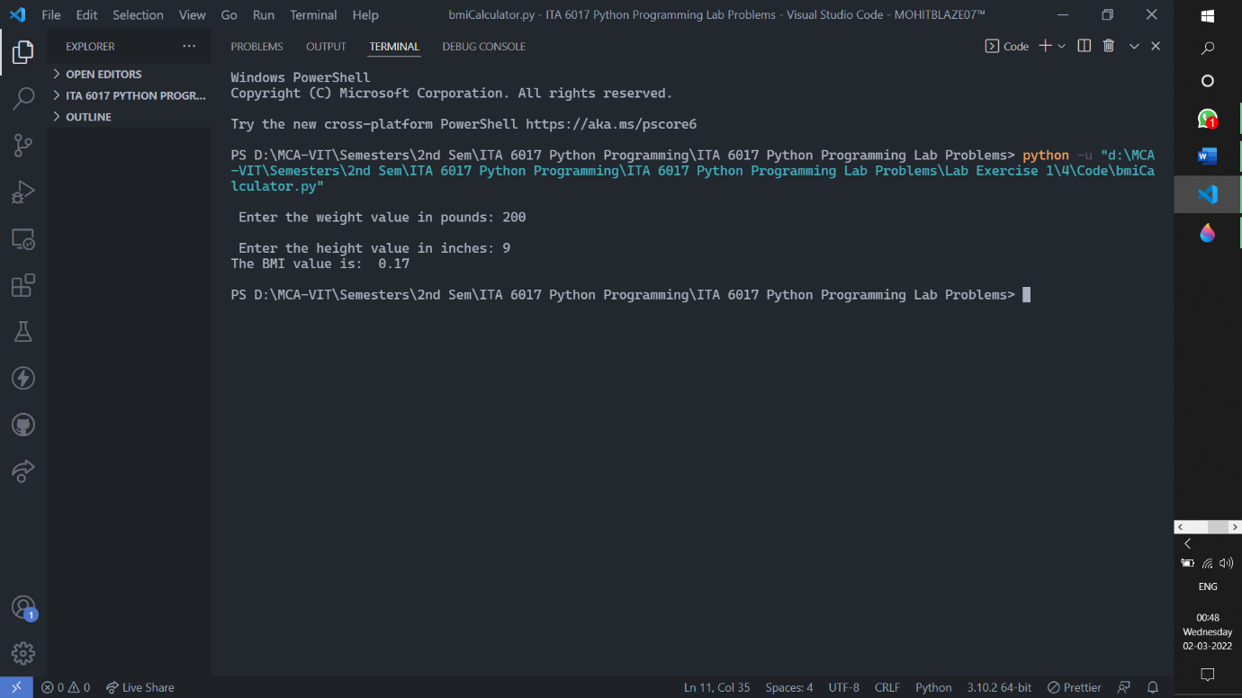

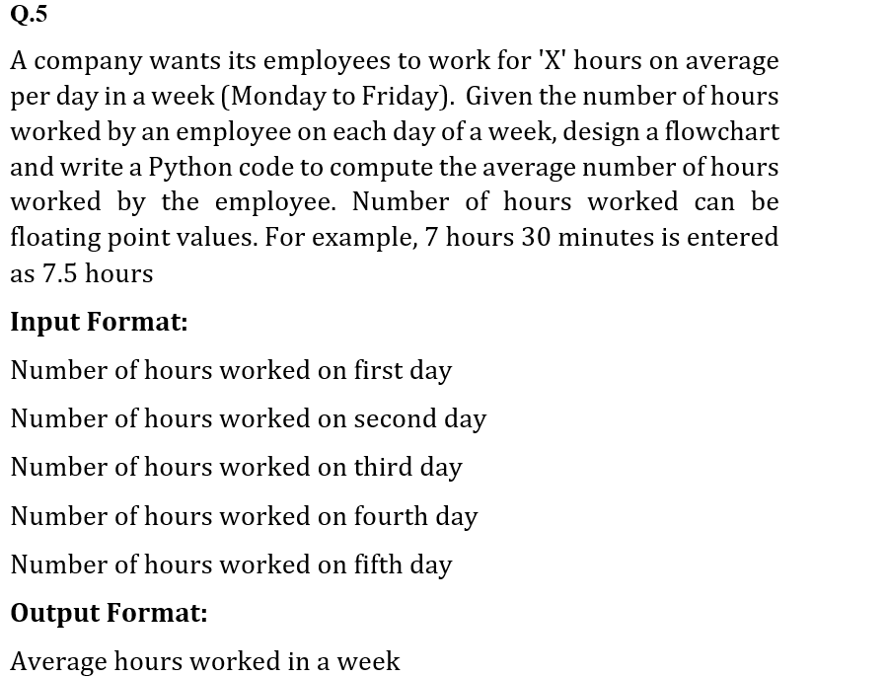

**CODE:**

firstDay = float(input("\n Enter the hours worked in first day: "))

secondDay = float(input("\n Enter the hours worked in second day: "))

thirdDay = float(input("\n Enter the hours worked in third day: "))

fourthDay = float(input("\n Enter the hours worked in fourth day: "))

fifthDay = float(input("\n Enter the hours worked in fifth day: "))

sumOfHoursWorked = firstDay + secondDay + thirdDay + fourthDay + fifthDay

avgHoursWorked = sumOfHoursWorked / 5

print("The average hours worked by the employee is: ", avgHoursWorked,"\n")

**SCREENSHOT OF OUTPUT:**

